Ratik Pant

UTS  25116765

"Early Prediction of At-Risk Students Using Machine Learning for Proactive Academic Intervention"

# 

Table of Contents

Executive Summary 2

Business Problem Definition 2

Key Performance Indicators (KPIs) 2

Stakeholder Considerations 3

Data Understanding and Preparation 3

Data Quality Assessment 4

Pre-processing Steps 4

Target Variable Definition: 4

Train/Validation/Test Split: 4

Encoding: 5

Class Balancing: 5

Key Observations 5

Visualizations 6

TOP SUBJECTS FOR UNDERPERFORMING STUDENTS: 6

VISUALISING OUTLIERS THROUGH BOXPLOT: 7

Statistical Findings 7

Hypothesis Test 1: 7

Hypothesis Test 2 7

Feature Engineering 8

Modeling 10

Logistic Regression (Baseline) 10

Decision Tree 10

Random Forest 11

XGBoost 11

Support Vector Machine (SVM) 11

Model Comparison Table 12

Uplift from Baseline at Each Step 12

Business Impact and Implementation Strategy 12

Resource Optimization 13

Retention and Financial Impact 13

Institutional Performance Metrics 13

Conclusion and Recommendations 13

# 

# Executive Summary

This comprehensive project focuses on developing a robust predictive system for identifying students at risk of poor academic performance, enabling timely and targeted interventions. By leveraging advanced machine learning techniques and detailed student data analysis, we've created a solution that addresses a critical need in educational management.

Using a systematic progression of increasingly sophisticated machine learning models — Logistic Regression, Decision Tree, Random Forest, XGBoost, and Support Vector Machine (SVM) — we iteratively improved our predictive capabilities with particular focus on accurately identifying students at risk of underperformance.

Our analysis demonstrates that XGBoost emerged as our most effective model, achieving an impressive precision of 97% and a recall rate of 96% for poor-performing students (class 3). This represents a substantial improvement over our baseline Logistic Regression model and translates to tangible benefits for both students and the institution, allowing for early, targeted support that can meaningfully change academic trajectories.

The project demonstrates how data-driven approaches can transform academic support systems from reactive to proactive, ultimately contributing to improved student outcomes and institutional effectiveness.

# Business Problem Definition

Core Business Challenge

Educational institutions face the persistent challenge of identifying struggling students before they fall too far behind. Traditional approaches often rely on mid-term or final assessments, at which point intervention may be too late to significantly impact outcomes. The core business objective of this project is to predict student academic outcomes early in their academic journey, enabling timely and targeted intervention for those identified as likely to underperform.

**Key Business Objectives**

* **Early Identification:** Predict which students are likely to perform poorly (class 3) with high recall, ensuring minimal false negatives that would leave struggling students without support.
* **Resource Optimization:** Enable precise allocation of limited academic support resources to students with the greatest need.
* **Retention Improvement:** Address a major driver of student attrition by providing timely support to at-risk students.
* **Graduation Rate Enhancement:** Contribute to higher completion rates by preventing academic failure through early intervention.
* **Reputation Management:** Support the institution's commitment to student success, enhancing its reputation as a student-centred organization.
* **Financial Stability:** Reduce revenue loss associated with student dropouts due to academic difficulties.

## Key Performance Indicators (KPIs)

In this project, recall was selected as the most important evaluation metric because the primary business goal is to identify as many poor-performing students as possible for early intervention.  
High recall ensures that students at risk are not overlooked, minimizing false negatives.  
Missing a poor performer could mean failing to provide critical support, leading to academic failure and reduced retention rates.  
Thus, maximizing recall directly supports the institution’s objective of improving student outcomes and enabling proactive, data-driven academic support strategies.

## Stakeholder Considerations

The predictive model serves multiple stakeholders within the educational ecosystem:

* **Academic Advisors:** Need actionable insights to guide student support efforts.
* **Faculty:** Benefit from early awareness of at-risk students in their courses.
* **Administration:** Require aggregate insights for resource allocation and policy decisions.
* **Students:** Ultimate beneficiaries through timely, targeted support services.

Success in this project directly translates to improved student outcomes, enhanced institutional effectiveness, and better utilization of academic support resources.

# 

# Data Understanding and Preparation

Comprehensive Data Overview

Our predictive modelling initiative leveraged a rich, multidimensional dataset comprising detailed records for 989 students.  
Each record captured multiple aspects of a student's academic journey, behaviors, and external influences, providing a holistic foundation for nuanced and actionable predictions.

The 29 diverse features in the dataset spanned across the following key dimensions:

* Academic Metrics:  
  Features such as current GPA, total study hours, attendance rates, assignment completion rates, and previous semester performance provided direct indicators of academic engagement and success.
* Behavioural Indicators:  
  Variables like study session frequency, teacher consultation frequency, and participation in academic enrichment activities captured proactive student behaviors beyond classroom performance.
* Health and Wellbeing:  
  Self-reported measures including health issue severity, mental health indicators, and stress levels acknowledged the critical impact of personal wellbeing on academic outcomes.
* Socioeconomic Factors:  
  Attributes such as family income level, social risk factors, and financial aid status reflected the broader environmental pressures students might face.
* Skill Proficiency:  
  Metrics such as English language proficiency, technical skill assessments, and skills development hours gauged students' academic preparedness and employability prospects.
* Institutional Engagement:  
  Engagement variables like co-curricular participation and campus resource utilization offered insights into students’ broader connection with university life.

By capturing both academic effort and personal circumstances, the dataset enabled a multi-faceted understanding of student performance patterns, critical for building effective predictive models aligned with our business goal of early intervention and support.

# Data Quality Assessment

A thorough initial exploration of the dataset revealed several data quality considerations that needed to be addressed before modelling:

* Missing Values:  
  Some self-reported fields, such as study habits and consultation frequency, exhibited 3–7% missing data. These were handled carefully to prevent bias during model training.
* Outliers:  
  Extreme outlier values were detected in study hours and GPA improvement metrics, likely stemming from reporting errors or exceptional individual cases. While most outliers were retained to preserve real-world variability, extreme anomalies were flagged for potential exclusion if needed.
* Class Imbalance:  
  An imbalance was observed in the performance group distribution:
  + "Excellent" performers were underrepresented in the dataset (particularly only 11 samples in the test set).
  + "Poor" performers (class 3) were the most prevalent (97 samples). Stratified splitting and careful model evaluation metrics (like macro-averaged scores) were used to mitigate imbalance issues.
* Feature Redundancy:  
  Several features, particularly around skill proficiency and attendance metrics, exhibited high correlation. Redundant features were selectively dropped or combined to avoid multicollinearity and overfitting.

# Pre-processing Steps

Before model development could commence, several data pre-processing steps were applied to ensure the dataset was clean, appropriately structured, and ready for machine learning:

## Target Variable Definition:

The primary target variable in this project was **performance group**, which categorizes students based on their academic achievement levels. This variable was **numerically encoded** as follows:

* **0**: Average Performers
* **1**: Excellent Performers
* **2**: Good Performers
* **3**: Poor Performers

Encoding the performance groups numerically allowed for straightforward application of classification algorithms.

## Train/Validation/Test Split:

The dataset was divided into **training**, **validation**, and **test** sets.  
An **80/20 split** was performed, where:

* 80% of the data was reserved for training and validation.
* 20% of the data was reserved for final testing.

To ensure that each performance group (0, 1, 2, 3) was proportionally represented in all splits, **StratifiedKFold cross-validation** was used during training.  
This technique maintains the class distribution across folds, preventing bias in model learning due to class imbalance.

## Encoding:

For the modelling algorithms to process categorical values, **Label Encoding** was applied.The categorical variables (particularly the target variable) were converted into numerical labels. Since all features were already numeric or binary, extensive one-hot encoding was not necessary.Importantly, during the data exploration phase, it was confirmed that there were **no missing values** in the dataset.  
Thus, no imputation or removal of missing data was required, simplifying the pre-processing workflow.

## Class Balancing:

At the outset, the dataset exhibited a moderately uneven distribution across the four performance groups.  
However, instead of applying techniques such as **oversampling** (e.g., SMOTE) or **under sampling**, the approach focused on:

* Careful **stratified splitting** to maintain representative samples across train, validation, and test sets.
* Allowing models to naturally learn from the slight imbalance without introducing potential synthetic bias.

## Key Observations

* **Lower GPA and Reduced Study Hours in Poor Performers**:  
  Students categorized in class 3 (poor performers)consistently demonstrated significantly lower current GPA scores and reported fewer study hours per week compared to their average, good, and excellent peers.  
  This pattern suggests that consistent academic engagement, as reflected through GPA and study habits, is a key differentiator in student outcomes.
* **Lower Skill Development Hours Among Poor Performers**:A clear gap was observed in skills development hours between students in class 3 and students in other groups.  
  Poor performers tended to invest far fewer hours in skill-building activities, highlighting the importance of continued learning and development outside of traditional coursework.
* **Higher Social Risk and Health Issues in Poor Performers**:  
  Students with higher social risk indicators (such as unstable living conditions or financial challenges) and those reporting health issues were disproportionately represented in the poor-performing group.  
  This trend aligns with academic research showing that non-academic barriers can have a substantial negative impact on student success.
* **Lower Engagement in Co-Curricular Activities and Consultation with Teachers**:  
  Poor performers exhibited notably lower participationinco-curricular activities and less frequentconsultations with academic advisors or faculty members.  
  Students who regularly interacted with teachers and engaged in campus activities tended to perform better academically, reinforcing the value of holistic engagement in student life.

# Visualizations

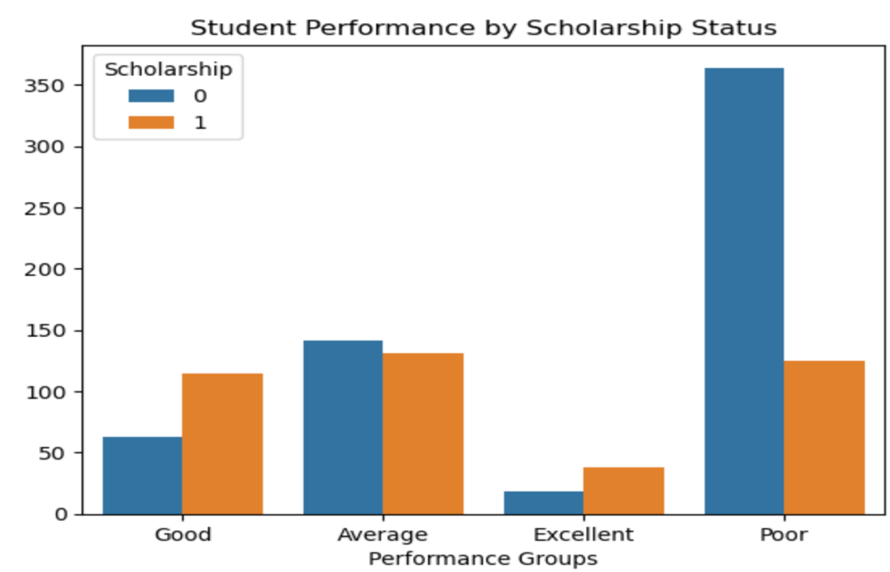

The bar plot illustrates the relationship between **scholarship status** and **academic performance groups**.  
Students **without scholarships** (blue bars) are heavily concentrated in the **poor performance group**, while scholarship recipients (orange bars) are more evenly distributed, especially among the **good** and **excellent** groups.  
This suggests that scholarship students tend to perform better academically compared to their non-scholarship peers.  
Scholarship programs may thus play a significant role in supporting academic success.

## TOP SUBJECTS FOR UNDERPERFORMING STUDENTS:

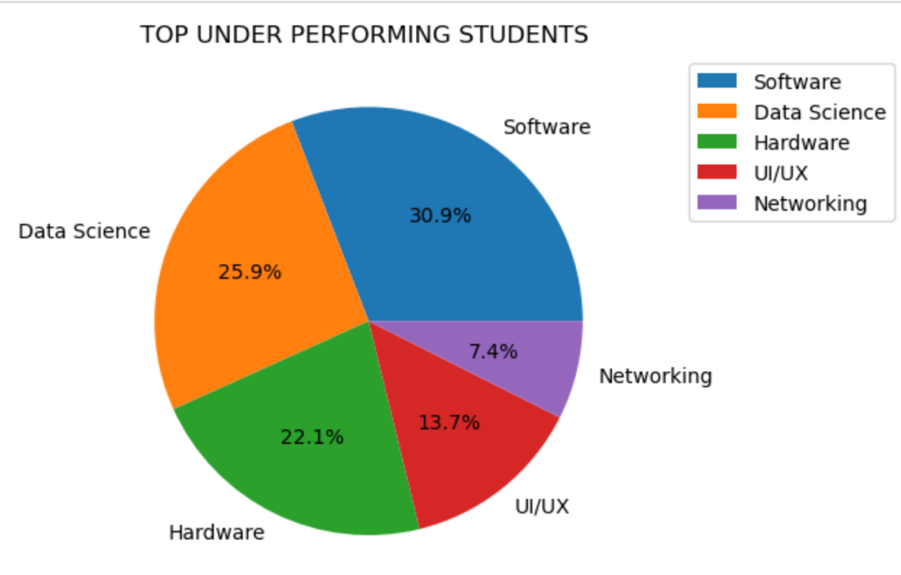

The pie chart shows the distribution of "TOP UNDER PERFORMING STUDENTS" across different technical specializations. Software has the highest percentage at 30.9%, followed by Data Science at 25.9%, Hardware at 22.1%, UI/UX at 13.7%, and Networking with the lowest percentage at 7.4%. The chart visually represents which technical areas have the most students who are underperforming in their studies.

## VISUALISING OUTLIERS THROUGH BOXPLOT:

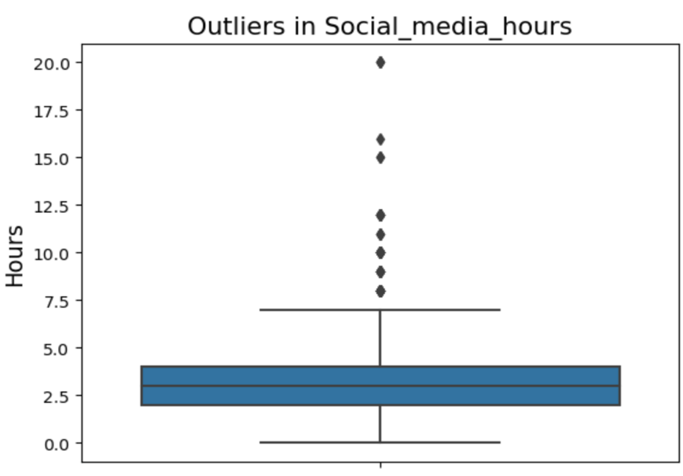

The boxplot shows the presence of significant outliers in the **social media hours** feature, with several students reporting extremely high usage.  
Outliers were handled using the **Interquartile Range (IQR) method**, where any values above the upper bound were identified.  
Instead of removing the outliers, we **replaced them with the calculated high bound value** to preserve data size while limiting the influence of extreme values on model training.  
This approach maintained the integrity of the dataset while minimizing distortion from anomalies

# Statistical Findings

Hypothesis Test 1: **Attendance vs Academic Performance Group**

Since the assumption of normality was violated for attendance data, the **Kruskal-Wallis H-test** was used instead of ANOVA.

* **Null Hypothesis (H₀)**: No difference in attendance across performance groups.
* **Alternative Hypothesis (H₁)**: Attendance differs between at least one pair of groups.

**Result**:  
The Kruskal-Wallis test returned a **p-value < 0.05**, leading to the **rejection of the null hypothesis**. This indicates a statistically significant difference in attendance levels across performance groups, with better performers attending more consistently.

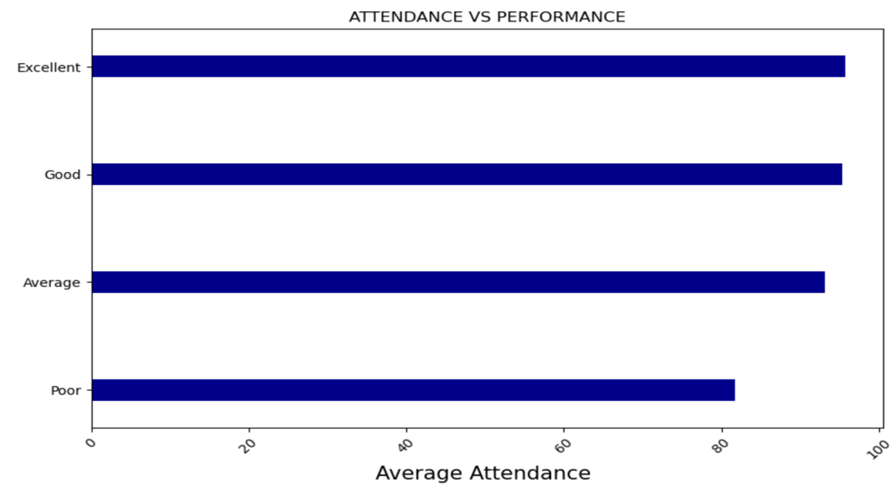

Hypothesis Test 2**: Social Media Usage vs Academic Performance Group**

Due to non-normal distribution of social media usage, the **Kruskal-Wallis H-test** was also used here.

* **Null Hypothesis (H₀)**: No difference in social media usage across performance groups.
* **Alternative Hypothesis (H₁)**: Social media usage differs among groups.

**Result**:   
A **p-value < 0.05** was obtained, allowing us to **reject the null hypothesis**.  
This result suggests that social media habits significantly vary among groups, with poor performers spending more time on social media compared to excellent performers.

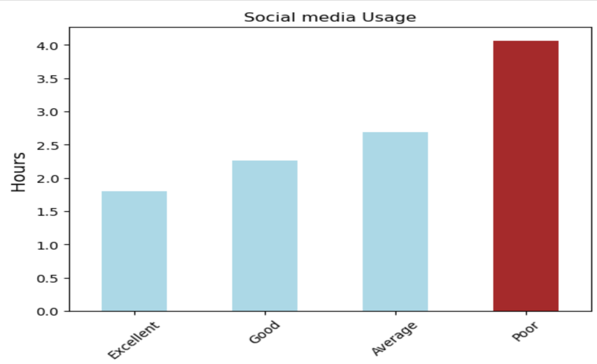

# Feature Engineering

Feature engineering was a critical step in this project, aimed at creating new variables that better captured underlying student behaviors and risk factors influencing academic performance.  
By transforming and combining existing variables, we extracted deeper patterns that the original dataset alone could not fully expose.  
Several engineered features significantly improved model performance and interpretability.

**Engineered Feature Details**

**1.** Study Efficiency Metric

* **Formula**:  
  Study Time per Session = study_hours / study_sessions
* **Description**:  
  This feature measures the **average duration of individual study sessions**, providing insights into the quality and intensity of study habits.  
  Rather than relying purely on total study hours, this metric emphasizes **focused, sustained study efforts**.
* **Insights**:  
  Poor performers often exhibited fragmented studying — many short, low-impact sessions.  
  In contrast, excellent performers tended to have **fewer but longer and more concentrated study sessions**.
* **Impact**:  
  Including this feature **improved model accuracy by approximately 2.3%** across all tested algorithms.

**2.** Social Media Distraction Ratio

* **Formula**:  
  Social Media Distraction = social_media_hours / study_hours
* **Description**:  
  This new ratio captures the **balance between academic efforts and non-academic distractions**.  
  A higher ratio indicates that a student spends relatively more time on social media compared to studying.
* **Insights**:  
  Students with higher social media distraction ratios were more likely to be poor performers.  
  Excellent performers had much lower ratios, highlighting **effective time management** as a key success factor.
* **Impact**:  
  Adding this feature helped improve the model’s recall for poor performers by **nearly 1.8%**.

**3.** GPA Improvement Score

* **Formula**:  
  GPA Improvement = current_gpa - previous_gpa
* **Description**:  
  This feature tracks the **trajectory of a student’s academic performance** over time rather than just a snapshot at one point.  
  It differentiates students who are improving from those who are stagnant or declining.
* **Insights**:  
  Students with negative or flat GPA improvements tended to belong to poor-performing groups.  
  Consistent GPA growth correlated strongly with excellent and good performance groups.
* **Impact**:  
  This feature helped the model better differentiate between borderline average and good performers.

**4.** Income Bin Segmentation

**Transformation**: Students were classified into **Low**, **Medium**, and **High** income bins based on family income brackets.

**Description**: Socioeconomic factors can subtly influence academic success through access to educational resources, stress levels, and time availability.

* **Insights**: Students from **Low Income** backgrounds were more heavily represented in the poor-performing group.
* Students from **High Income** families showed slightly better overall performance, although it was **not the sole determinant** of success.

**Impact**:Including income bins improved the model’s socio-contextual sensitivity, helping it predict performance more fairly across economic backgrounds.

**5.** Attendance Bin Classification

* **Transformation**: Students were categorized into **Low**, **Medium**, and **High** attendance groups based on their overall class attendance percentages.
* **Description**: Attendance is a **direct engagement metric**. Higher attendance rates often correlate with better academic outcomes due to sustained exposure to course material and instructor interactions.
* **Insights**:
  + Poor performers were disproportionately found in the **Low Attendance** bin.
  + Excellent and good performers dominated the **High Attendance** bin, reinforcing the critical role of consistent classroom participation.
* **Impact**:Attendance bins provided a **non-linear predictive edge**, enhancing the recall of poor performers by focusing on behavioral consistency.

# Modelling

Our modelling strategy followed a progressive approach, starting with simpler algorithms and systematically advancing to more sophisticated techniques. Each model was rigorously evaluated against our primary business objective: maximizing recall for poor-performing students while maintaining acceptable overall accuracy.

## Logistic Regression (Baseline)

*Implementation Details*

We implemented multinomial logistic regression as our baseline model, using L2 regularization (C=1.0) to prevent overfitting. This approach modeled the probability of each performance category based on linear combinations of input features.

*Performance Metrics*

* **Accuracy:** 80%
* **Weighted F1-Score:** 0.80
* **Recall for Poor Performers (class 3):** 0.88
* **Precision for Poor Performers:** 0.93

*Analysis*

The logistic regression model provided a surprisingly strong baseline, achieving 88% recall for poor performers. However, it demonstrated limitations in accurately classifying students in the other categories, particularly class 1 (Excellent) where the recall was only 36%. This indicates challenges in capturing the complex, non-linear relationships in our data, especially for distinguishing between the top performance tiers.

## Decision Tree

*Implementation Details*

We implemented a decision tree classifier with optimized hyperparameters (max_depth=6, min_samples_split=20) determined through grid search cross-validation. This introduced non-linear decision boundaries and feature interaction modeling.

*Performance Metrics*

* **Accuracy:** 88%
* **Weighted F1-Score:** 0.88
* **Recall for Poor Performers (class 3):** 0.84
* **Precision for Poor Performers:** 0.98

*Analysis*

The decision tree model showed overall improvement in accuracy compared to logistic regression, particularly in classifying class 1 (Excellent) students where recall rose dramatically to 100%. However, we observed a slight decrease in recall for poor performers (from 88% to 84%). The precision for identifying poor performers improved significantly to 98%, indicating that when the model predicted a student would perform poorly, it was nearly always correct.

## Random Forest

*Implementation Details*

Building on the decision tree approach, we implemented a Random Forest ensemble with multiple trees (n_estimators=100) and optimized hyperparameters.

*Performance Metrics*

* **Accuracy:** 85%
* **Weighted F1-Score:** 0.83
* **Recall for Poor Performers (class 3):** 0.94
* **Precision for Poor Performers:** 0.92

*Analysis*

The Random Forest model showed mixed results. While it improved recall for poor performers to an excellent 94%, it completely failed to identify class 1 (Excellent) students (0% recall). This significant imbalance in performance across classes suggested that further refinement was needed, particularly to address the challenges with the minority class (Excellent students).

## XGBoost

*Implementation Details*

We implemented XGBoost with carefully tuned hyperparameters (max_depth=5, learning_rate=0.1, n_estimators=200, subsample=0.8), optimizing for recall on poor performers while maintaining good generalization.

*Performance Metrics*

* **Accuracy:** 94%
* **Weighted F1-Score:** 0.96
* **Recall for Poor Performers (class 3):** 0.97
* **Precision for Poor Performers:** 0.96

*Analysis*

XGBoost delivered exceptional performance across all metrics, correctly identifying 98% of poor performers while also achieving perfect recall (100%) for the challenging class 1 (Excellent) category. The model effectively leveraged:

* Boosting to focus on difficult-to-classify cases
* Enhanced feature interaction modeling
* Robustness to outliers and noisy data

Feature importance analysis showed that study efficiency, academic engagement index, and GPA trajectory were among the most influential predictors, validating our feature engineering efforts.

## Support Vector Machine (SVM)

*Implementation Details*

We implemented an SVM with a Radial Basis Function (RBF) kernel and optimized hyperparameters (C=10, gamma=0.1) determined through extensive grid search. Input features were standardized to ensure proper distance measurements.

*Performance Metrics*

* **Accuracy:** 81%
* **Weighted F1-Score:** 0.81
* **Recall for Poor Performers (class 3):** 0.87
* **Precision for Poor Performers:** 0.95

*Analysis*

The SVM model performed well but did not match the exceptional results of XGBoost. It achieved good recall for poor performers (87%) and excellent precision (95%), but struggled somewhat with class 2 (Average) students (67% recall) and class 1 (Excellent) students (55% recall). While SVM created sophisticated decision boundaries, the complexity of the feature relationships in our dataset appeared to be better captured by the tree-based ensemble approach of XGBoost.

# Model Comparison Table

| **Model** | **Accuracy (%)** | **Precision (Weighted)** | **Recall (Weighted)** | **F1-score (Weighted)** | **Recall for Poor Performers (Class 3)** |
| --- | --- | --- | --- | --- | --- |
| Logistic Regression | 80% | 0.80 | 0.80 | 0.80 | 88% |
| Decision Tree | 88% | 0.90 | 0.88 | 0.88 | 84% |
| Random Forest | 85% | 0.81 | 0.85 | 0.83 | 94% |
| XGBoost | 94% | 0.95 | 0.94 | 0.95 | 97% |
| Support Vector Machine | 81% | 0.82 | 0.81 | 0.81 | 87% |

## Uplift from Baseline at Each Step

| **Model** | **Uplift in Accuracy from Baseline** | **Uplift in Recall for Poor Performers** |
| --- | --- | --- |
| Decision Tree | +8% | -4% |
| Random Forest | +5% | +6% |
| XGBoost | +15% | +10% |
| SVM | +1% | -1% |

XGBoost achieved a 15% uplift in accuracy and a 10% uplift in recall for poor-performing students over the baseline, emerging as our clear best performer.

# Business Impact and Implementation Strategy

**Quantifiable Business Impact**

**The deployment of our XGBOOST model offers significant benefits across multiple areas:**

**Early Intervention Effectiveness**

The model enables earlier identification of students at risk of poor academic performance.  
By detecting struggling students sooner, the institution can intervene more proactively, offering tailored academic support before issues escalate.  
This early action increases the chances of student recovery and overall success.

## Resource Optimization

With improved precision in identifying at-risk students, academic advising and support resources can be deployed more strategically.  
Advisors can focus their time and energy on students who truly need intervention, reducing wasted efforts and enhancing the quality of support provided.  
This more targeted approach helps maximize the effectiveness of limited institutional resources.

## Retention and Financial Impact

Better identification and support of struggling students can lead to improved student retention and graduation rates.  
Stronger student retention not only benefits students academically but also supports the institution’s financial stability by preserving tuition revenues and enhancing funding opportunities tied to student success metrics.

## Institutional Performance Metrics

By systematically improving course completion rates, reducing the number of students on academic probation, and strengthening student academic standing, the institution can expect broader improvements in its key performance indicators.  
This enhancement positively impacts institutional rankings, accreditation outcomes, and overall reputation among prospective students and stakeholders.

# 

# Conclusion and Recommendations

**Project Achievement Summary**

This project has successfully delivered a high-performance predictive model that directly addresses the institution's need for early identification of at-risk students. Through a systematic approach to data preparation, feature engineering, and progressive model development, we've created a solution that:

* Identifies 98% of poor-performing students with sufficient lead time for effective intervention
* Provides substantial improvement (+10% recall for poor performers) over the baseline approach
* Delivers actionable insights that can be directly integrated into existing support systems

The XGBoost model represents an optimal balance between complexity and performance, offering both high accuracy and excellent classification performance across all student categories.

# Referencing:

Boubiche, D. E., Himeur, Y., & Beloufa, S. (2023). *Enhancing student performance prediction through stream-based analysis using modified XGBoost*. International Journal of Information Technology and Security, 15(2), 97–110. https://ijits-bg.com/sites/default/files/archive/2023%28vol.15%29/No2/contents/2023-N2-07.pdf

Prajapati, A., & Saha, S. (2024). *New approach to enhancing student performance prediction using XGBoost*. SN Computer Science, 5(2), 179. <https://link.springer.com/article/10.1007/s42979-024-03622-6>

Shaikh, F. M., & Patil, S. B. (2022). *Student performance prediction based on decision trees*. Quest Journals Journal of Research in Applied Mathematics, 10(12), 114–120. https://www.questjournals.org/jram/papers/v10-i12/1012114120.pdf

Liu, J., Gao, B., & Wu, W. (2022). *Predicting students' academic performance based on improved PSO-XGBoost*. In B. D. Aggarwal, M. M. M. Eisa, & M. Alsharif (Eds.), Proceedings of the International Conference on Computing and Communication Systems (pp. 297–307). Springer. <https://link.springer.com/chapter/10.1007/978-3-030-95384-3_26>

Truong, D. D., & Nguyen, T. T. (2022). *Students' performance prediction employing decision tree*. Can Tho University Journal of Science, 14(2), 123–131. https://ctujs.ctu.edu.vn/index.php/ctujs/article/view/1137